Name: Pratyush Kumar
Reg. No.: 19BCE0506
Slot: L41+L42
Course: CSE2005, Operating Systems

LAB FAT

1.

Code:

#include <stdio.h>
#include <stdlib.h>
#include <unistd.h>

int main()
{
int n, r, i, j;

printf("Enter the number of processes: ");
scanf("%d", &n);

printf("\n");

printf("Enter the number of resources: ");
scanf("%d", &r);

printf("\n");

int max[n][r], alloc[n][r], avail[r], need[n][r], req[r];

for (i = 0; i < n; i++) {
printf("Enter the maximum requirement matrix for process P%d: ", i);
for (j = 0; j < r; j++) {
scanf("%d", &max[i][j]);
}
}

printf("\n\n");

for (i = 0; i < n; i++) {
printf("Enter the current allocation matrix for process P%d: ", i);
for (j = 0; j < r; j++) {
scanf("%d", &alloc[i][j]);
}
}

printf("\n\n");

printf("Enter the initial available matrix");
for (i = 0; i < r; i++)
{
scanf("%d", &avail[i]);
}

printf("\n\n");

printf("Content of NEED matrix is: \n");
for (i = 0; i < n; i++) {
for (j = 0; j < r; j++) {
need[i][j] = max[i][j] - alloc[i][j];
printf("%d ", need[i][j]);
}
printf("\n");
}

printf("\n");

int f[n], ans[n], ind = 0;
for (i = 0; i < n; i++) {
f[i] = 0;
}

int count = 0, y;
do
{
for (i = 0; i < n; i++) {
if (f[i] == 0) {

int flag = 0;
for (j = 0; j < r; j++) {
if (need[i][j] > avail[j]){
flag = 1;
break;
}
}

if (flag == 0) {
ans[ind++] = i;
for (y = 0; y < r; y++)
avail[y] += alloc[i][y];
f[i] = 1;
count++;
}
}
}
} while (count != n);

if (count != n) {
printf("DEADLOCK HAS OCCURRED!!");
exit(0);
} else {
printf("SAFE Sequence is: \n");
for (i = 0; i < n; i++)
printf("P%d ", ans[i]);
printf("\n");
}

printf("\n");

printf("Need matrix: \n");
for (i = 0; i < n; i++) {
for (j = 0; j < r; j++) {
printf("%d ", need[i][j]);
}
printf("\n");
}

printf("Availability matrix: \n");
for (i = 0; i < r; i++) {
printf("%d ", avail[i]);
}

printf("\n");

printf("Enter the process number requesting");
scanf("%d", &y);

printf("Enter the instance of each resource type");
for (i = 0; i < r; i++) {
scanf("%d", &req[i]);
}

int flag = 0;
for (i = 0; i < r; i++) {
if (need[y][i] < req[i] && avail[i] < req[i]) {
flag = 1;
break;
}

if (flag == 0) {
avail[i] = avail[i] - req[i];
alloc[y][i] = alloc[y][i] + req[i];
need[y][i] = need[y][i] - req[i];
}
}
if (flag == 1) {
printf("Request not granted\n");
} else {
printf("Request granted\n");
}

return 0;
}

Screenshot

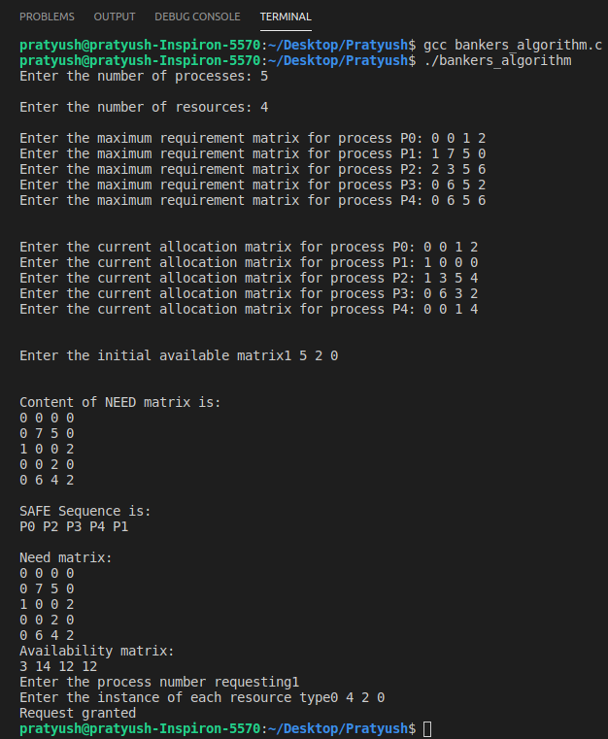

2.

Code

while :
do
clear
echo "MAIN - MENU"
echo "1. Date"
echo "2. Count the number of users logged in"
echo "3. Display free disk space"
echo "4. Display only the directories with the access permission and its size"
echo "5. Process status of the user"
echo "6. Display all created files"
read opt
case $opt in
1)
echo "Today is $(date)"
break;;
2)
echo "users $(w)"
break;;
3)
echo "free disk space $(df)"
break;;
4)
echo "display directories $(ls -l)"
break;;
5)
echo "processes status of the user $(ps)"
break;;
6)
echo "all created files $(ls)"
break;;
*)
echo "$opt is an invalid option. Please select option between 1-6 only";
echo "Press [enter] key to continue...";
read enterKey;;
esac
done

Screenshot

